In association with our In House partner
THE ART DECO AND MODERNISM SOCIETY OF NSW & ACT Inc

FRIDAY 23RD FEBRUARY 7:00 pm

The Poisoned Chalice: Peter Hall and
The Sydney Opera House

An illustrated talk by Dr Anne Watson
in the auditorium of the Australian Institute of Architects
at Tusculum 3 Manning Street POTTS POINT NSW 2011

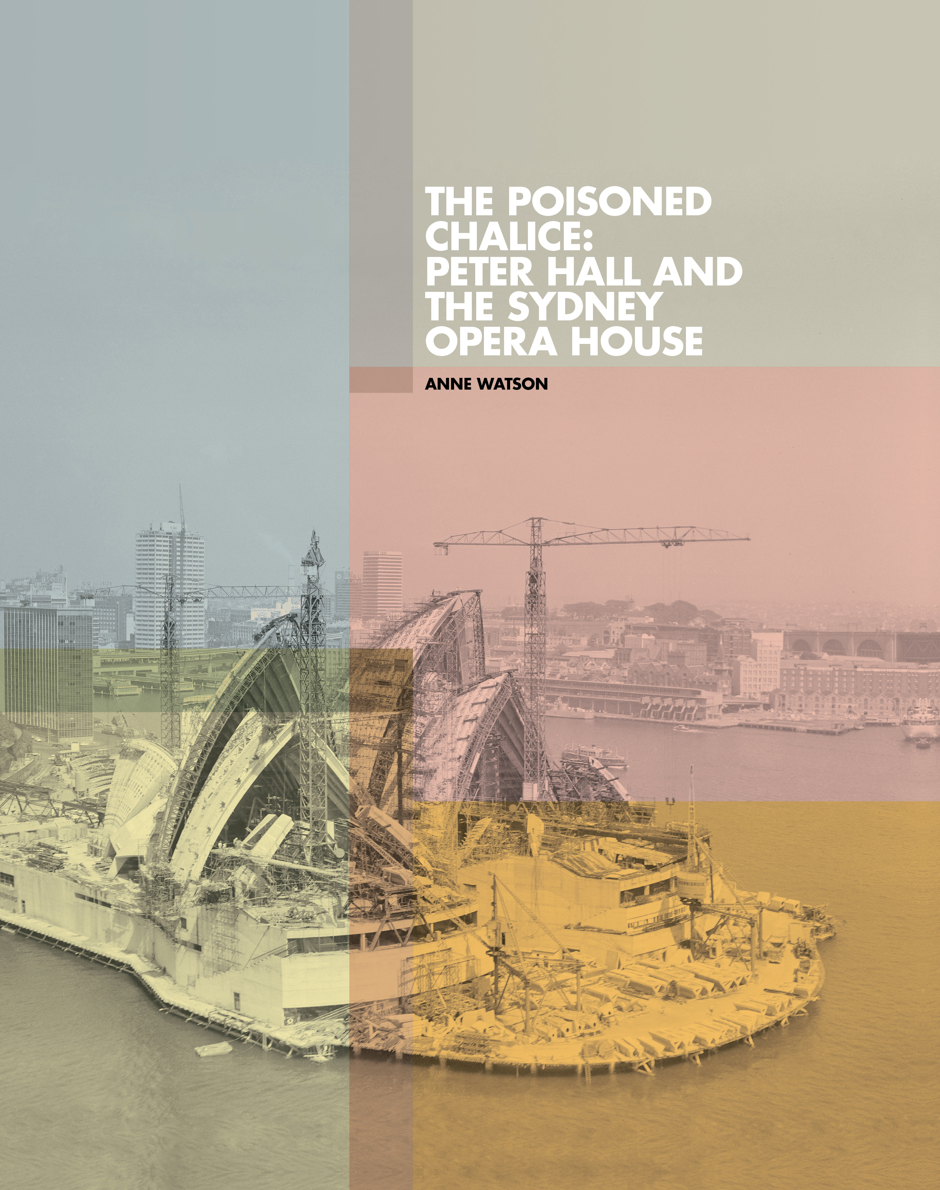

In February 1966 JørnUtzon spectacularly resigned from the Sydney Opera House project, never to return. His successor, Peter Hall, was faced with the near-impossible task of completing the building by steering the project thought the gridlock of problems that had defeated Utzon. Drawing on extensive original research this lecture explores the many dilemmas that Hall faced, the circuit-breaker solutions that facilitated progress – and suggests that Hall and his team deserve much greater recognition within the wider Opera House narrative.

Dr Anne Watson has an MA (Fine Arts) and PhD (Architecture) from Sydney University. Her long career as a design curator and writer has included many publications, with particular specialisations in the work of Marion Mahony and Walter Burley Griffin and the history of the Sydney Opera House. She recently published The Poisoned Chalice: Peter Hall and the Sydney Opera House (opusSOH, Sydney, 2017) based on her 2014 PhD research.

BOOKINGS & PAYMENTS: Please use ‘Eventbrite’ at http://www.twentieth.eventbrite.comwhere you can pay by VISA or MasterCard. Costs are: C20th / Art Deco & Modernism / AIA Members: $20 pp; Non Members: $25 pp; Concessions $15 pp.If you prefer to pay directly to the Society by EFT, details are: ANZ Bank, BSB: 012352, A/C: 270268971, A/C Name: Twentieth Century Heritage Society of NSW Inc. NB: Please include your name (i.e. DSmithTalk). If paying cash on the day please book on 02 98782511 leaving a message after the tone. Please bring the exact amount as we will not have a float.

